Campus ERP Updates 2

BANKING

The current it is Contains 4 sub-icons (four screens), including metadata only on the names of banks and the names of its branches and the accounts of the company only

I suggest that they are all merged into just one screen in the following format

And add small button after category to can add more categories in a popup:

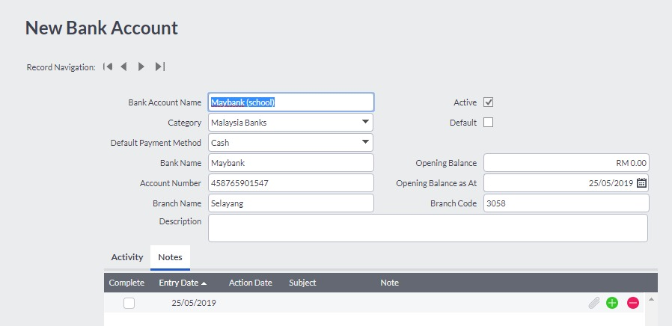

Keeping in mind that once the page is saved… .. an account (in the name of the bank-branch) is created in the accounts directory follows the current assets (hence linked to the accounts tree and then we can deal as a separate account)

Can merge all my banking transactions in one screen as follows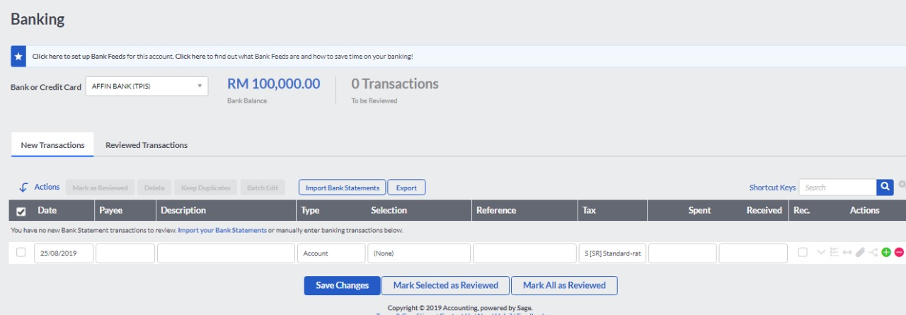

This screen includes several benefits, including payment and receipt of cash and checks Credit Card and any blood determine the beneficiary, and whether from students, customers, suppliers, bank transfer or any other entity can explain the previous screen as follows

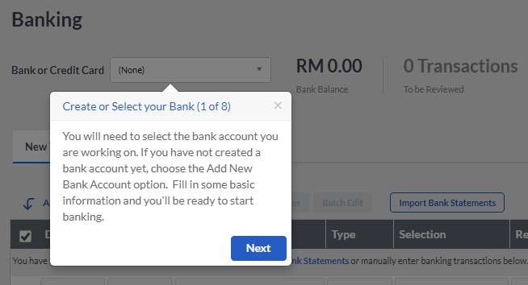

After selecting the name of the bank linked to the account in the directory of accounts, the process is recorded as follows

The date and name of the beneficiary are recorded and the process explained

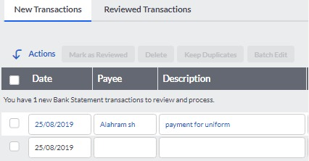

Then choose the type of beneficiary if it is in the directory of accounts or customers or suppliers or transfer to another bank account - taking into account when choosing the type changes the special section according to what was chosen

|  |  |
| --- | --- |
| C:\Users\Hany\Desktop\bank6.jpg | C:\Users\Hany\Desktop\bank5.jpg |

Then the last part of this screen is written the process number or reference and chooses the type of tax and write the amount, whether spent by the bank or deposited in the bank Received

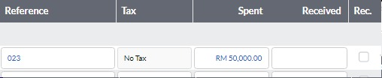

Note that after the completion of the required entries the screen will be as follows

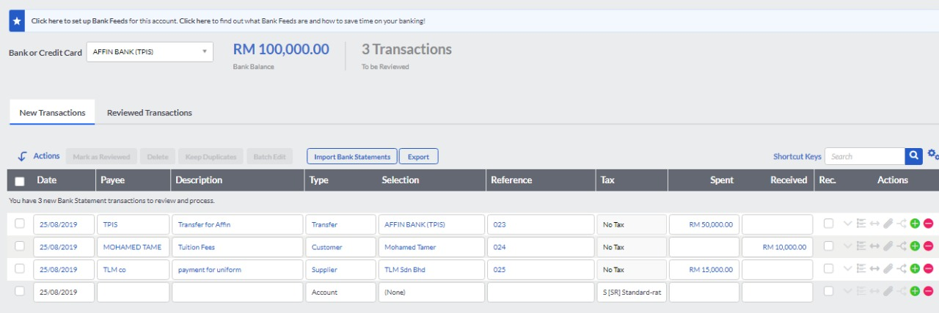

It is preferred to have an icon to upload the original invoice or original document 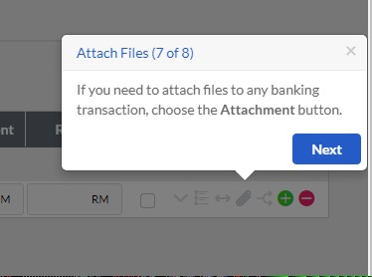

**Technical Note - Create daily entries and then post to the rest of the accounting cycle**

**When the save button is pressed, the program makes the necessary daily restrictions so that the bank account owes the amount received or credited the amount spent and the second party to the entry is the account chosen within the previous screen.**

Finally, these reports should include a full set of reports, for example the following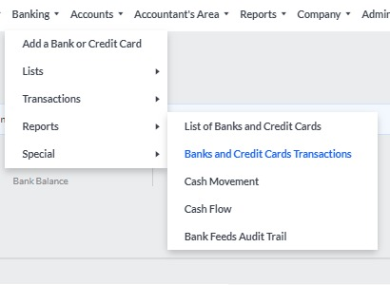

ASSETS

To be as create account tree in one page the structure and asset declaration:

Example

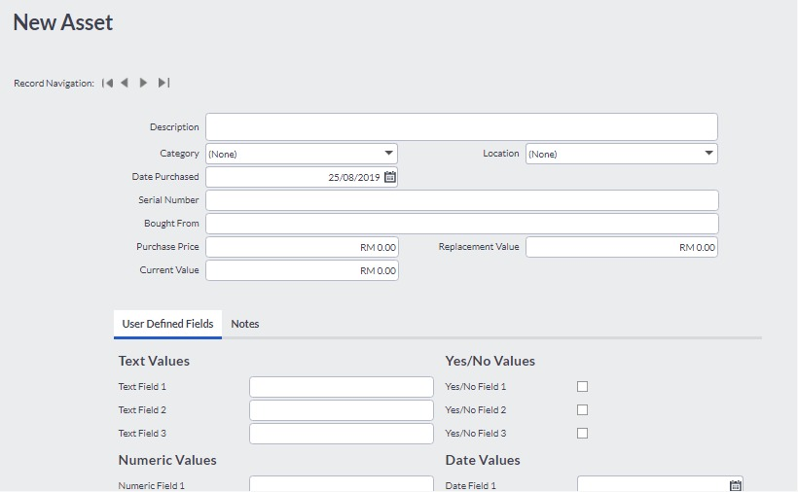

Suggest:

New Tab will be in one page:

New Category

Assets

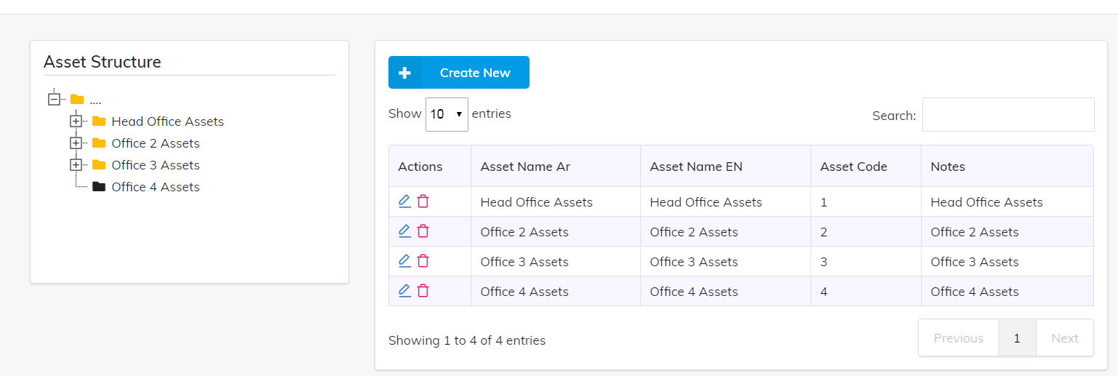

Technical note

When linking the asset to its account in the accounts directory, it is preferable to make the last level in the accounts directory only for selection…. Not all levels (as added in the restrictions section)

As well as Account Accumulated and depreciation expense

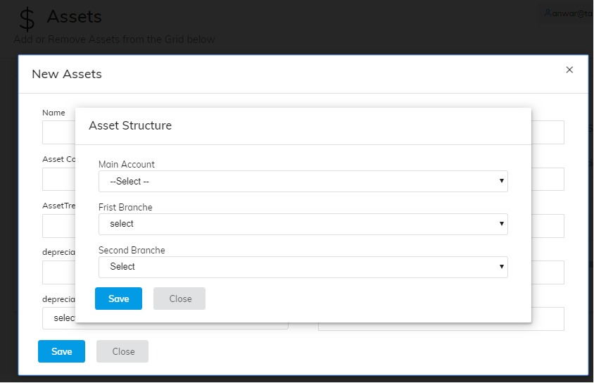

Assets Reports which we need

